**UI Prototype**

Group ID: **08**

Project Name: Ebook4U

Prepared by: **Vu Hoang Phuc**

Team members:

20120352 - **Vu Hoang Phuc** *Project manager*   
20120370 – **Trieu Quoc Thai** *Developer*   
20120373 – **Le Truong Kinh Thanh** *Tester*   
20120376 – **Tran Van That** *Business Analyst*

20120471 – **Truong Van Hao** *Developer*

Tool used: [***https://www.figma.com/***](https://www.figma.com/)

UI Design Link: <https://www.figma.com/file/WO4875OTjADIGuxftOiQpP/Untitled?node-id=137%3A2317&t=zOhjUoTjKMiMR8cd-1>

Table of Contents

**I)Reader** 3

**1)** **Login:** 3

**2)** **Register** 3

**3)** **Forget password** 4

**4)** **Home page** 5

**5)** **Search Not Found** 6

**6)** **Profile page** 6

**7)** **Favorite books** 7

**8)** **My Library** 8

**9)** **Update Profile** 9

**10)** **Read page** 10

**II)Admin** 11

**1)Admin Dashboard page** 11

**2) Users Management** 12

**3)** **Books management** 14

**4)** **Comment Management** 16

**5)** **Update a book** 16

**6)** **Add new book** 17

# **I)Reader**

1. **Login:**

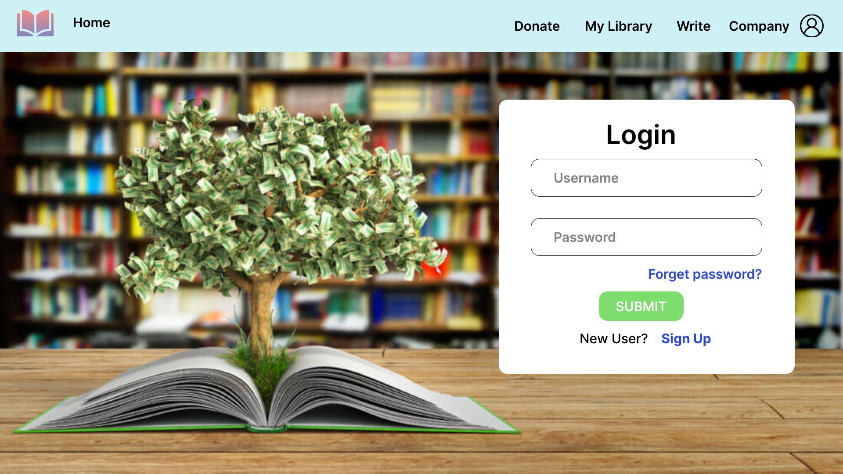

- You can Login by Username and password

- If you do not have an account,please click **Sign Up** to register an account

- If you forget your password, click **Forget password** button to go to the password reset page. You can see its UI in Section 3.

1. **Register**

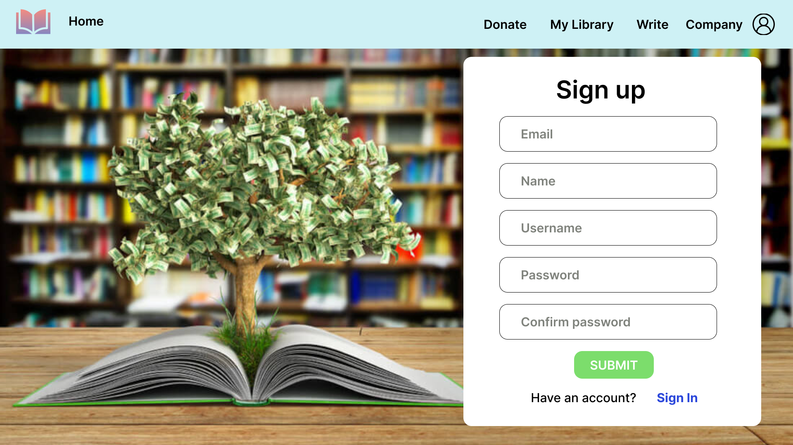

* To register a new account , it requires you to supply your email, name .
* If you already have an account, Click **Sign In** to sign in.

1. **Forget password**

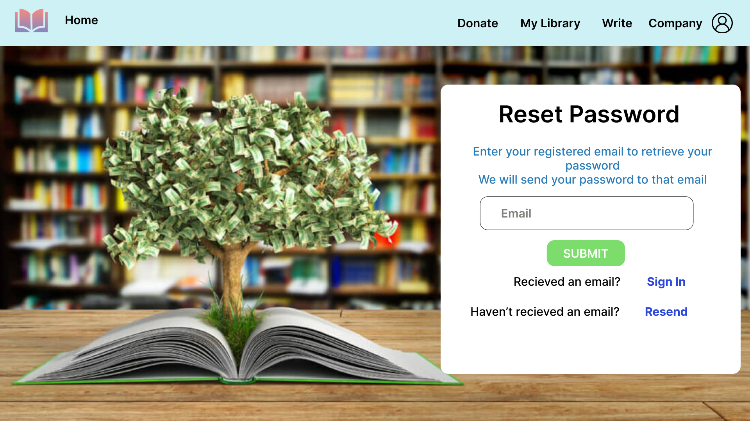

- You need to enter your registered email to retrieve your password

- The system will send your password to that email address and then you can Login

- If you haven’t received any email, Click **Resend** to resend the your password.

1. **Home page**

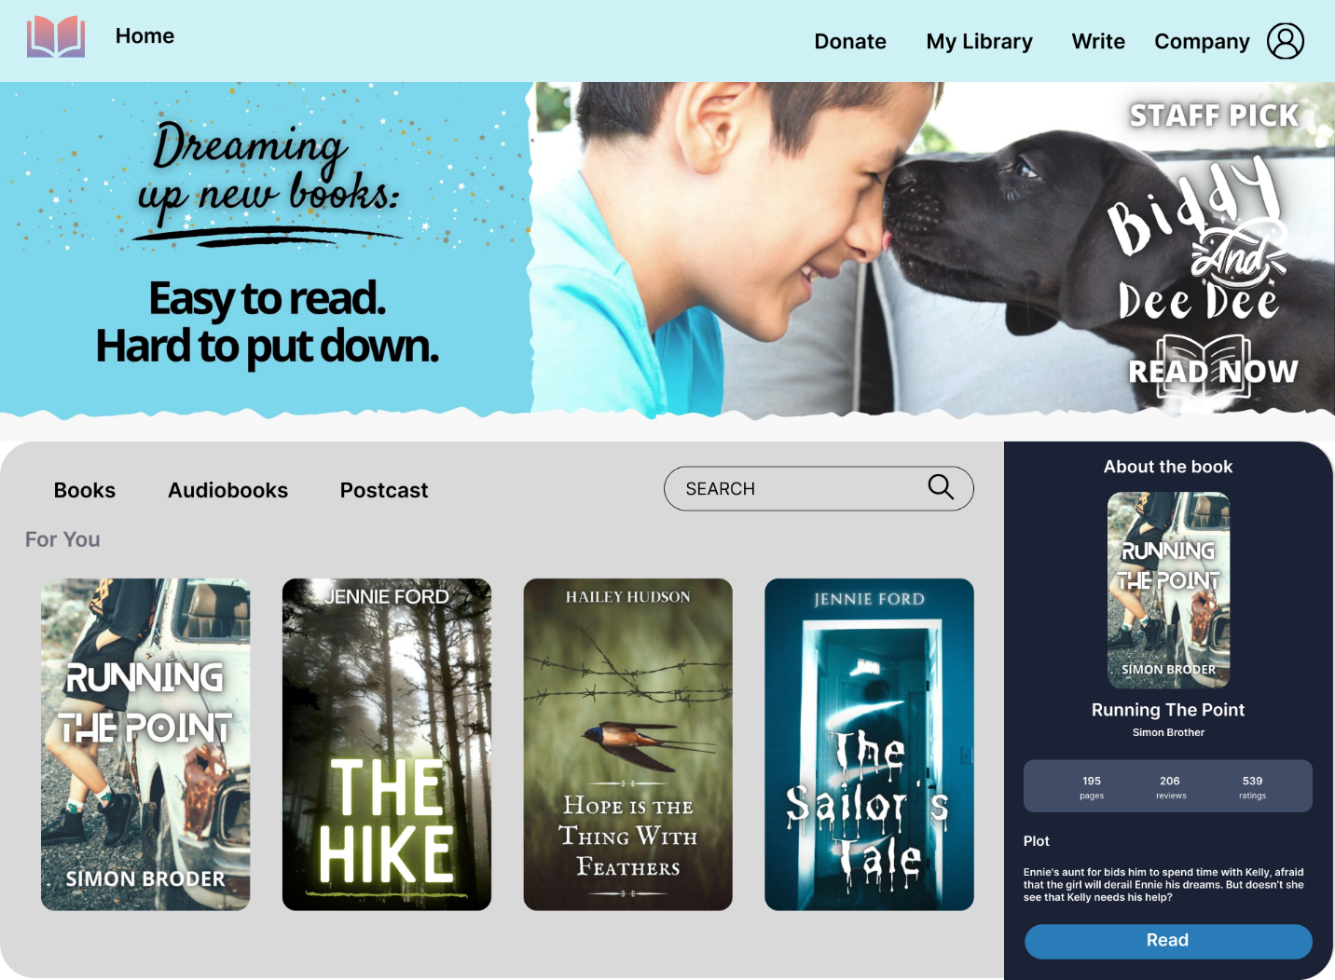

In this page, you can do a lot of thing.

-You can see some book recommended to you.

-You can use the search bar to search your book which you want to read: 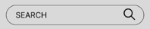

-When you click a cover image of a book, the details will appear in the “About the book” section

- If you want to read that book, click Read Button: . And then you will move to Read Page. You can see it in Section 10

- In header:

+Click **Home** to back to Home page

+Click **Donate** to support us.

+Click **Company** to view our team information

+Click **Write** to upload your book

+Click  to view or manage your profile. You can see it in Section 6.

+Click **My Library** to view your history viewed books. You can see it in Section 8

1. **Search Not Found**

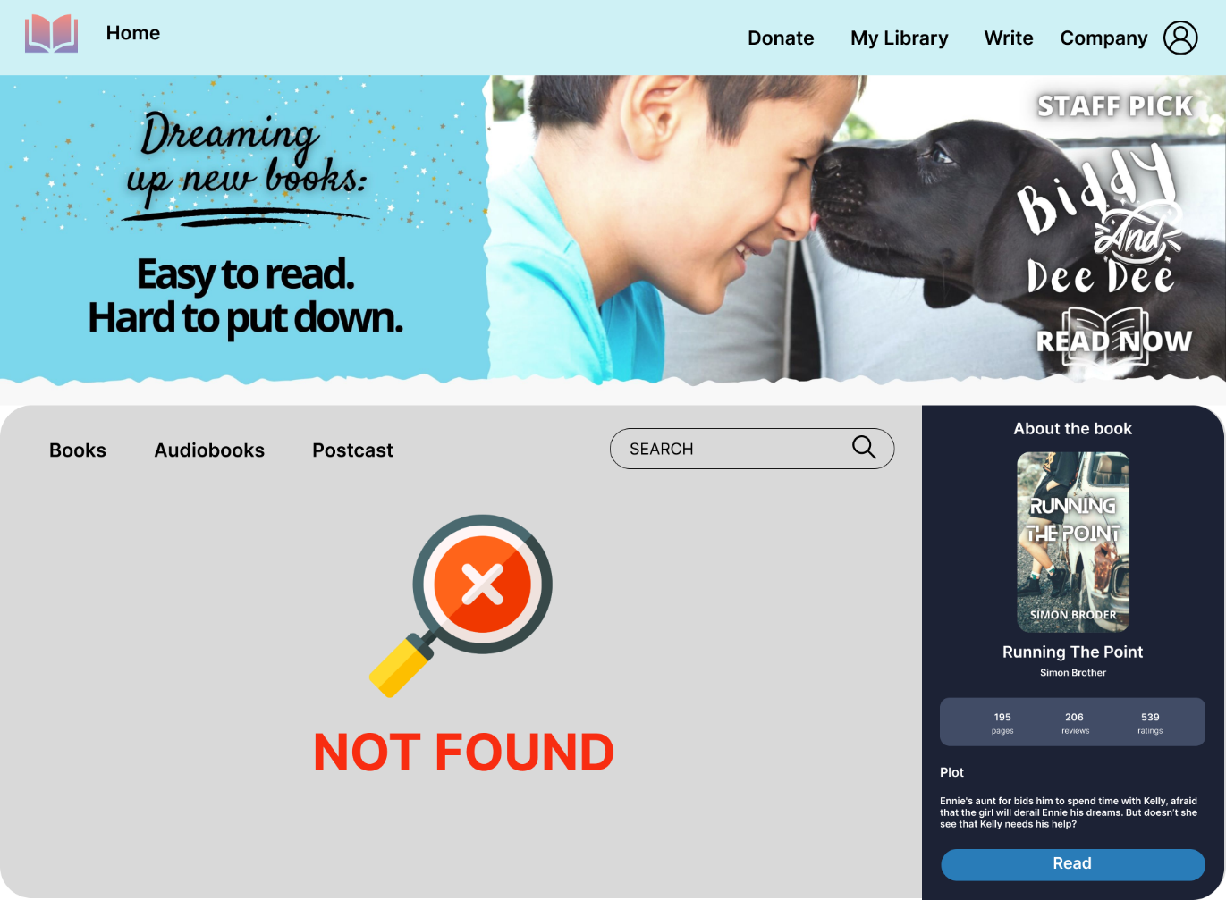

If your search is not found, system will report NOT FOUND.

1. **Profile page**

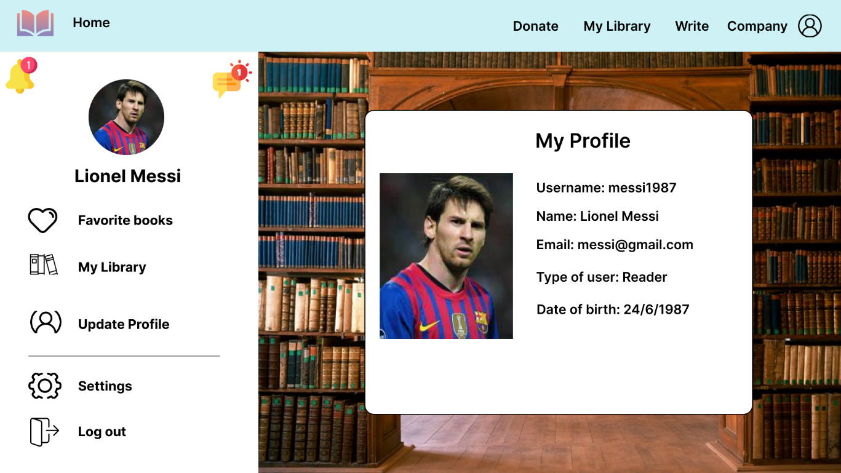

* Click **Favorite books** to view your favorite books. You can see it in the following Section
* Click **My Library** to view your history viewed books. You can see it in Section 8
* Click **Update Profile** to update your profile. You can see it in Section 9
* Click **Settings** to manage your settings
* Click **Log out** to sign out

1. **Favorite books**

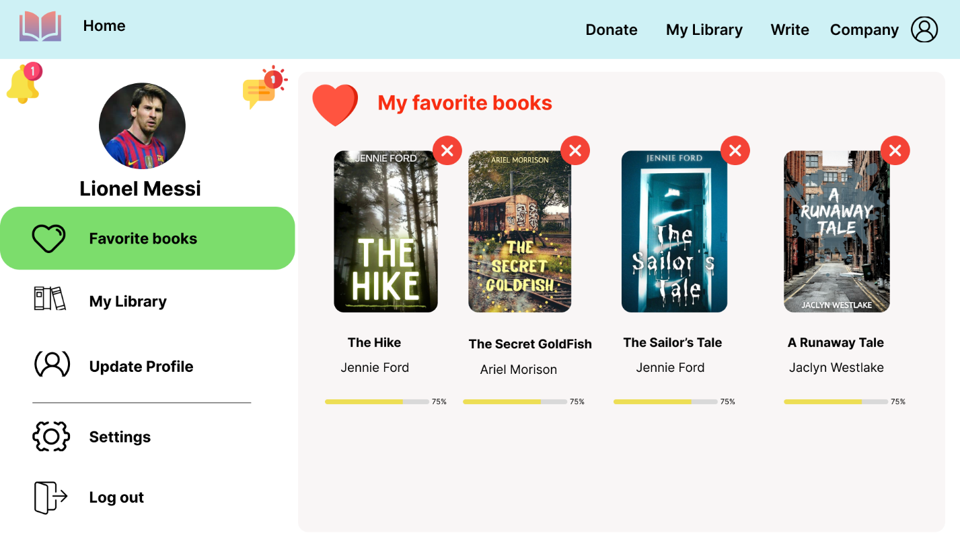

Click  to remove a book from this list

1. **My Library**

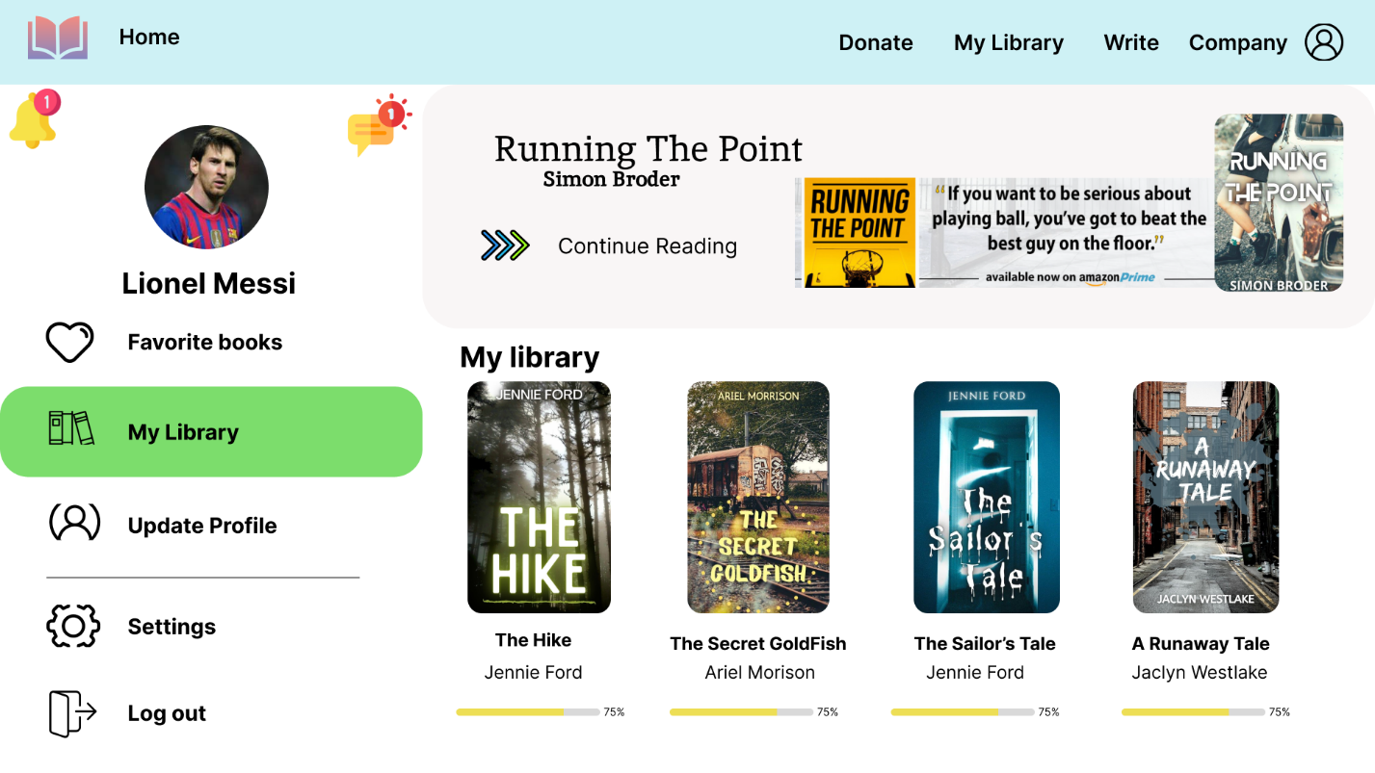

You can see your lastest book in the upper right corner. 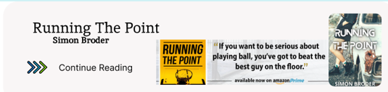

Click Continue Reading to finish the book

Besides, you can see your history viewed book with their process.

1. **Update Profile**

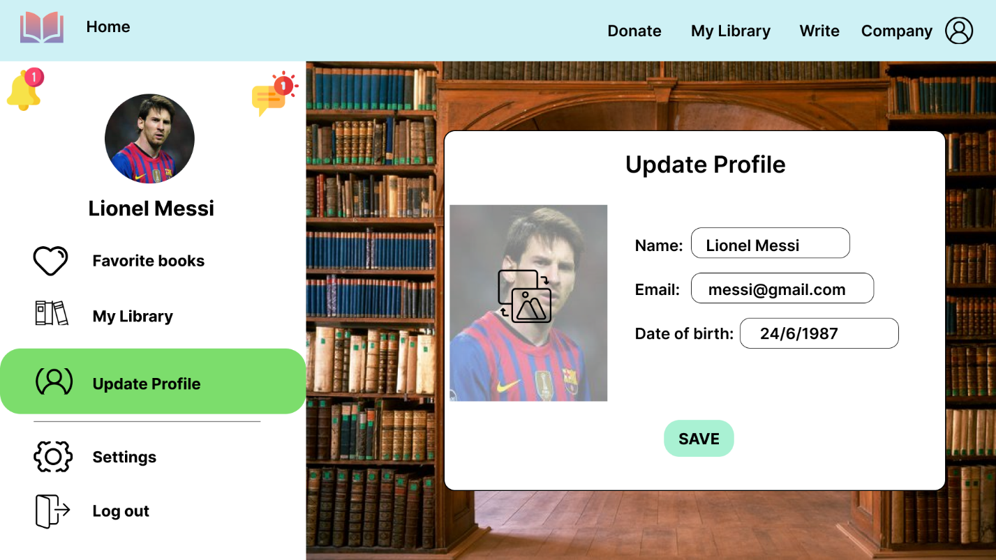

Click  to change your avatar.

Enter your new information and press Save Button

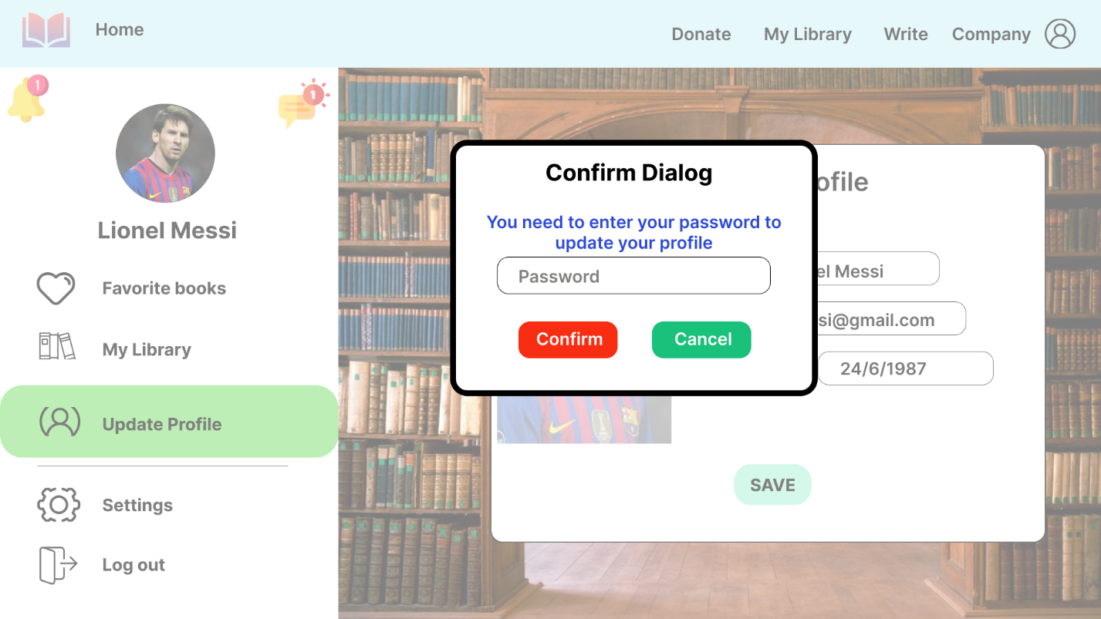

Then, you need to provide your password to save changes.

If you type password incorrectly, you won’t able to update your profile.

1. **Read page**

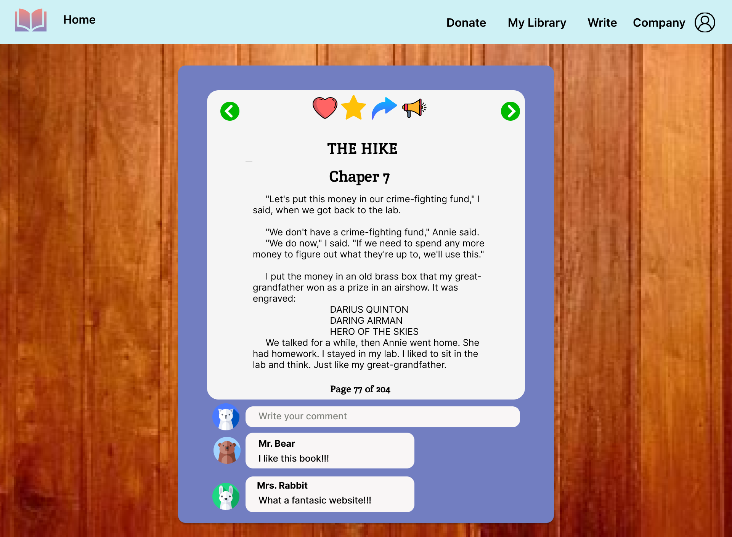

* Click  or  to go to the previous or the next page
* Click  to add this book to your Favorite books, Click this icon one more time to undo
* Click  to rate this book
* Click  to share this book
* Click  to report this book
* You can view the other ‘s comment or write your comment at the end of the page

# **II)Admin**

**1)Admin Dashboard page**

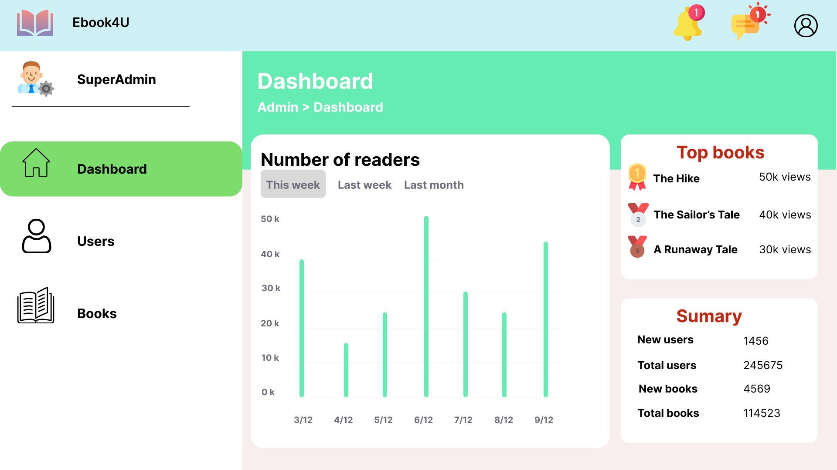

You can see the number of reader in this week, last week or last month

Click **Users** to manage User Account. You can see it in the following Section

Click **Books** to manage Book. You can see it in Section 13

## **2) Users Management**

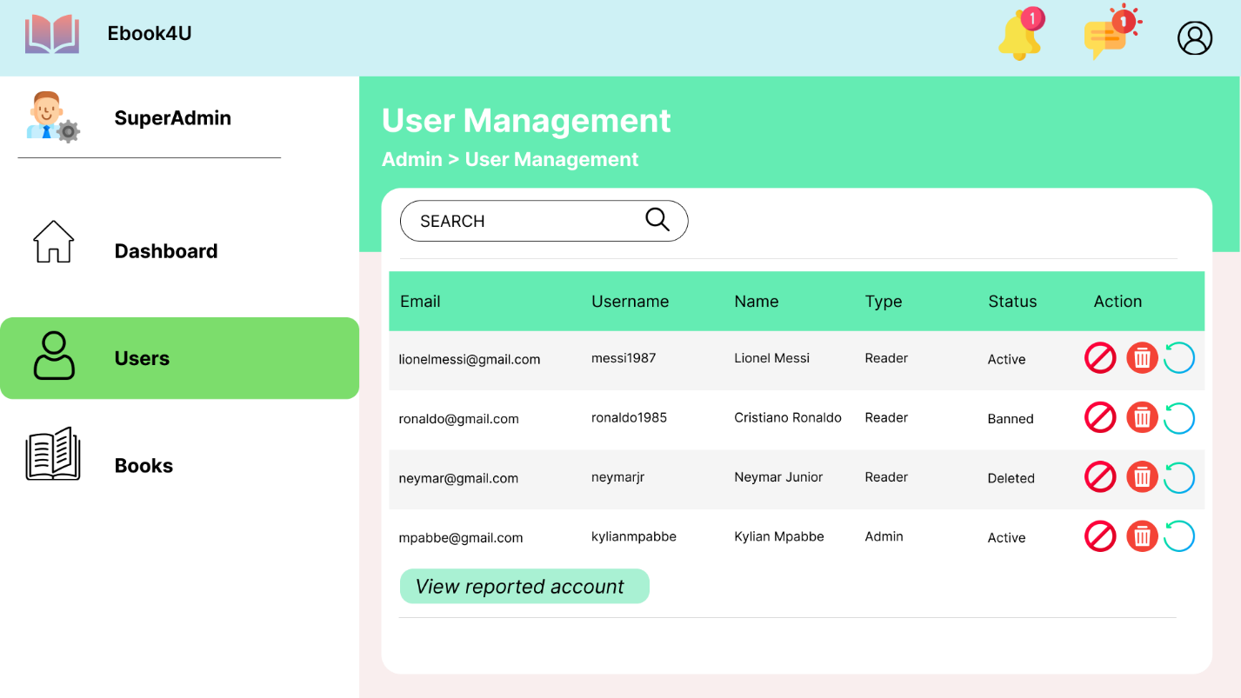

Use search bar to search an user account

* Click  to ban an user account. After that a confirm dialog will appear.

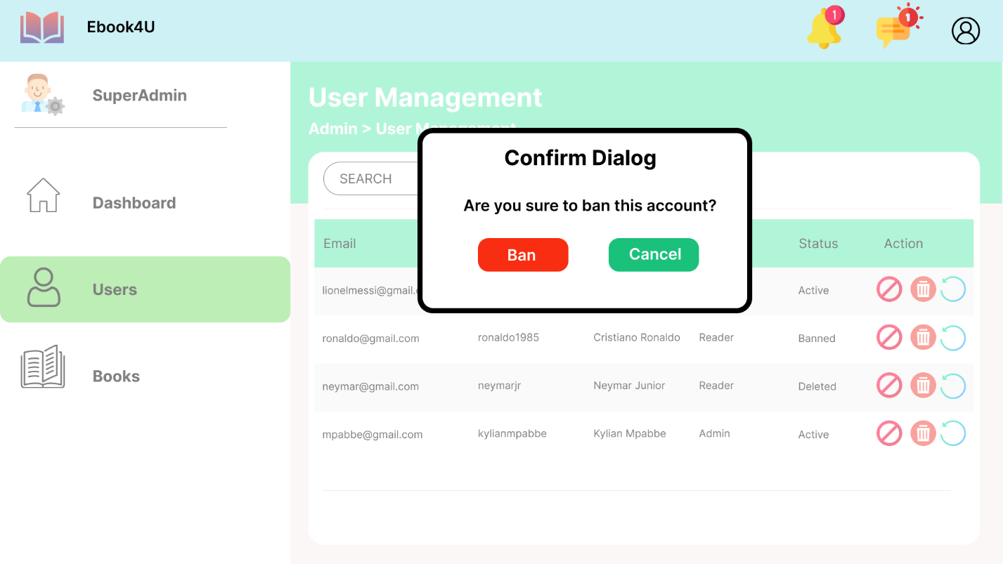

* Click  to delete an user account . After that a confirm dialog will appear.

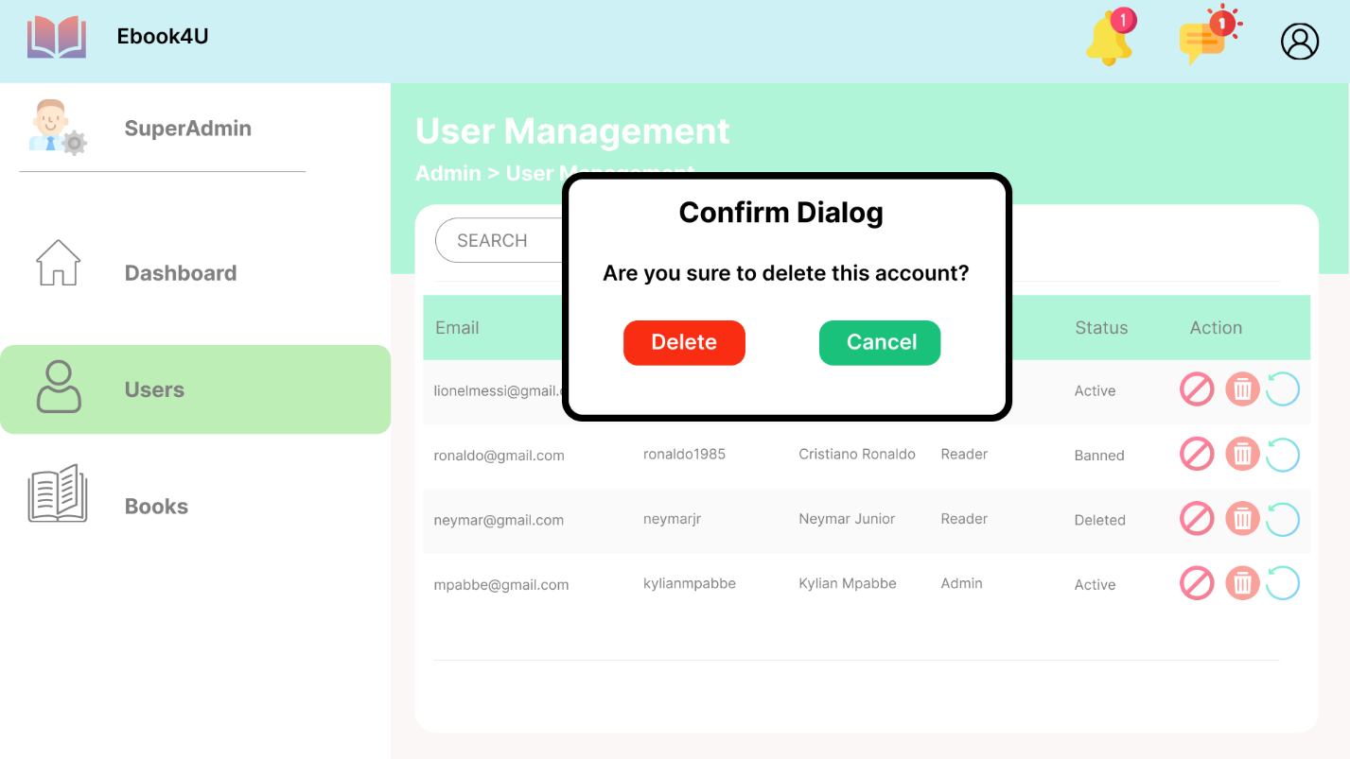

* Click  to unban an banned account. After that a confirm dialog will appear.

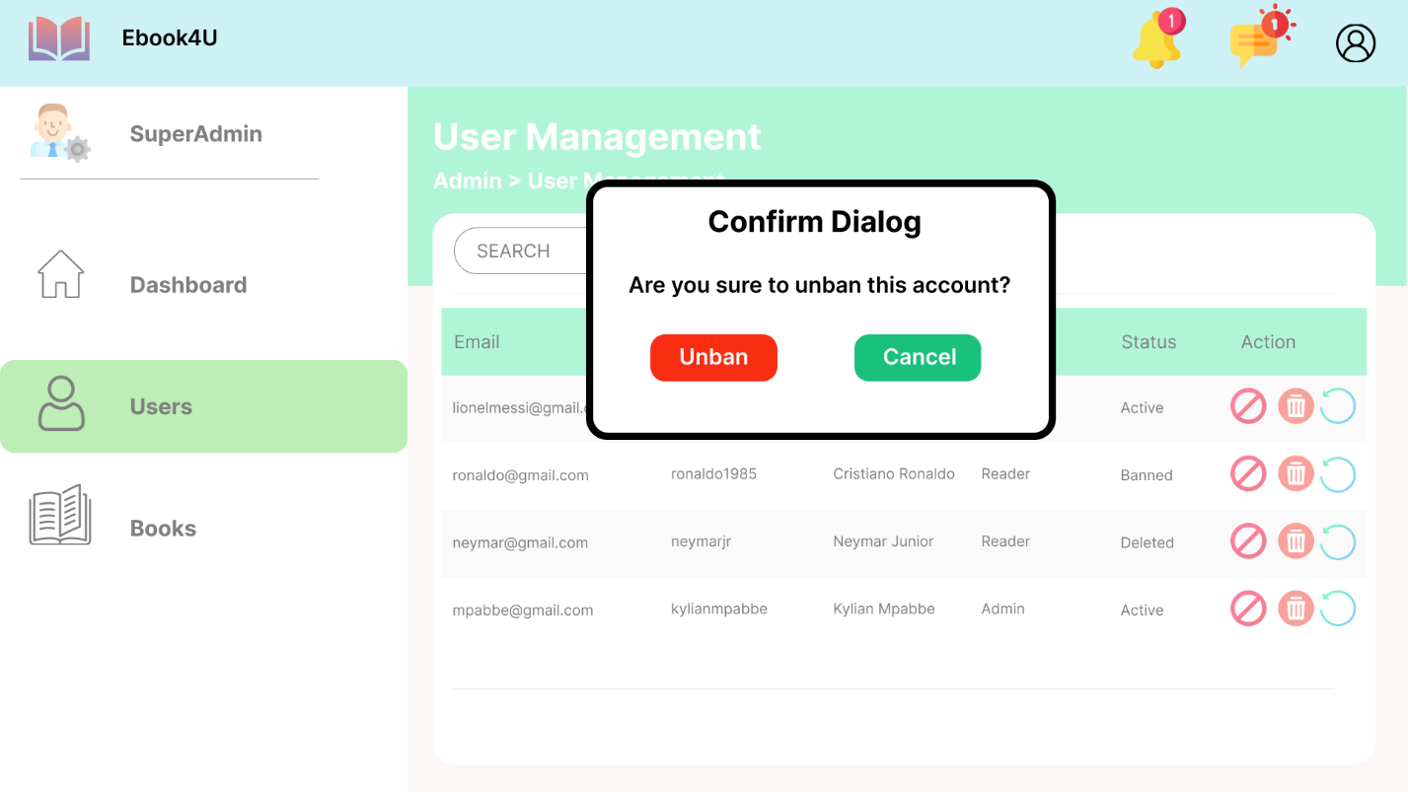

Click  to see list of reported accounts

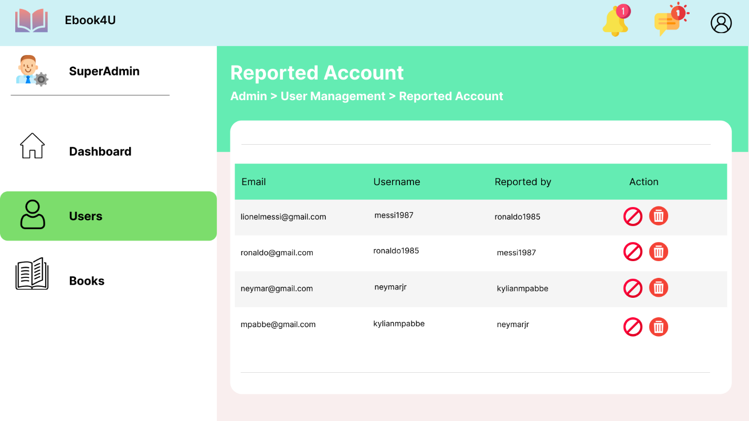

Use  and  as above.

1. **Books management**

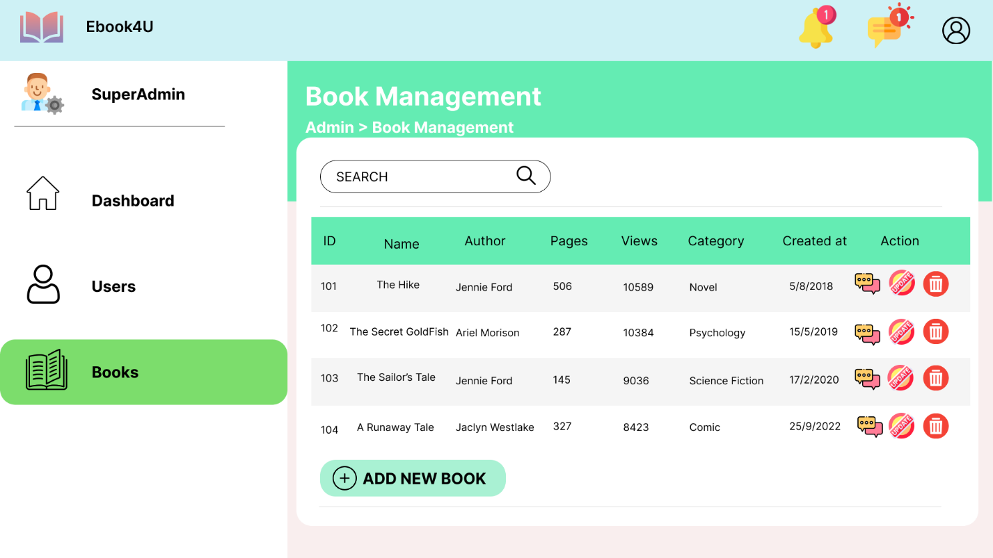

Click  to view all comments of this book. You can see it in Section 14

Click  to update a book. You can see it in Section 15

Click  to delete a book. After that a confirm dialog wil appear.

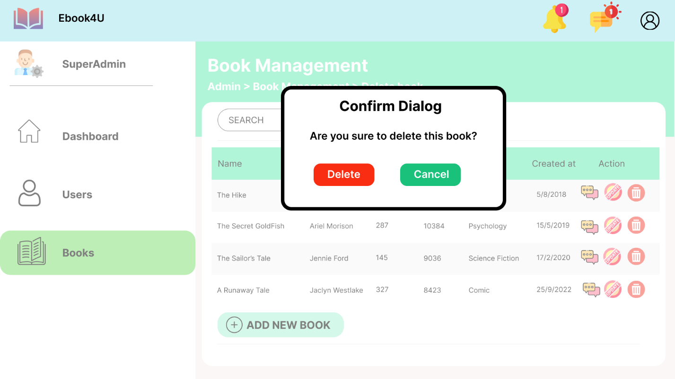

Click  to add a new book. You can see it in Section 16

1. **Comment Management**

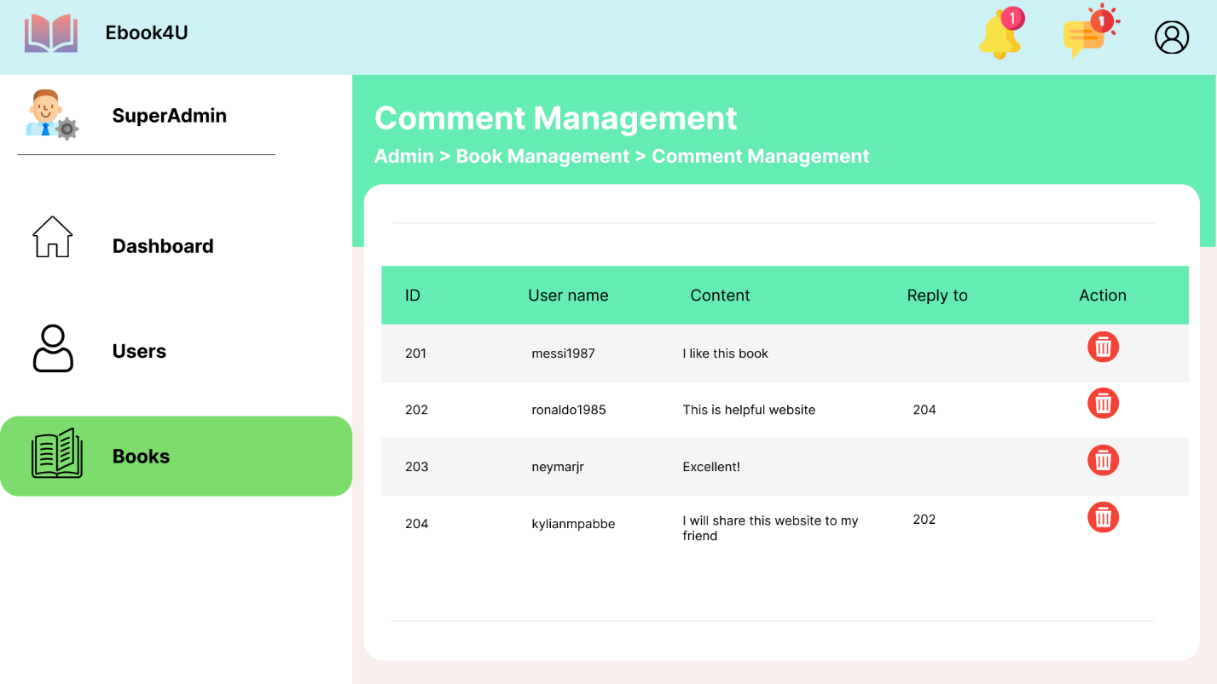

Click  to delete a comment

1. **Update a book**

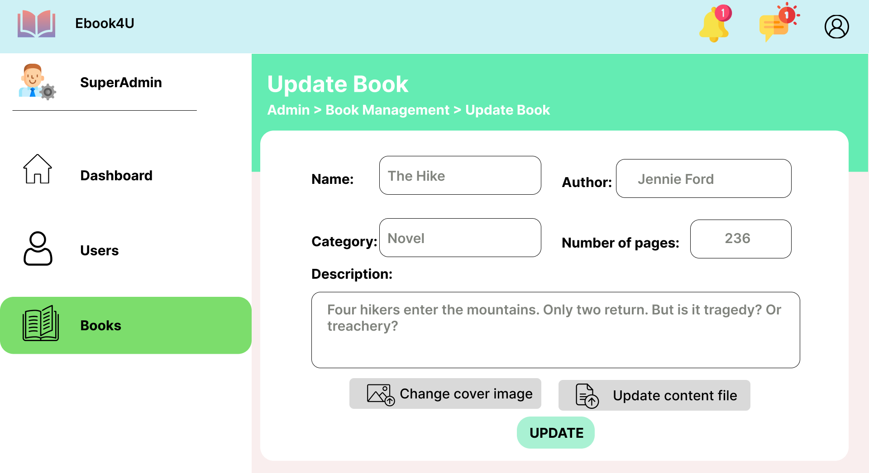

You need to enter new information of the book and press **UPDATE** button to submit.

After that a confirm dialog will appear.

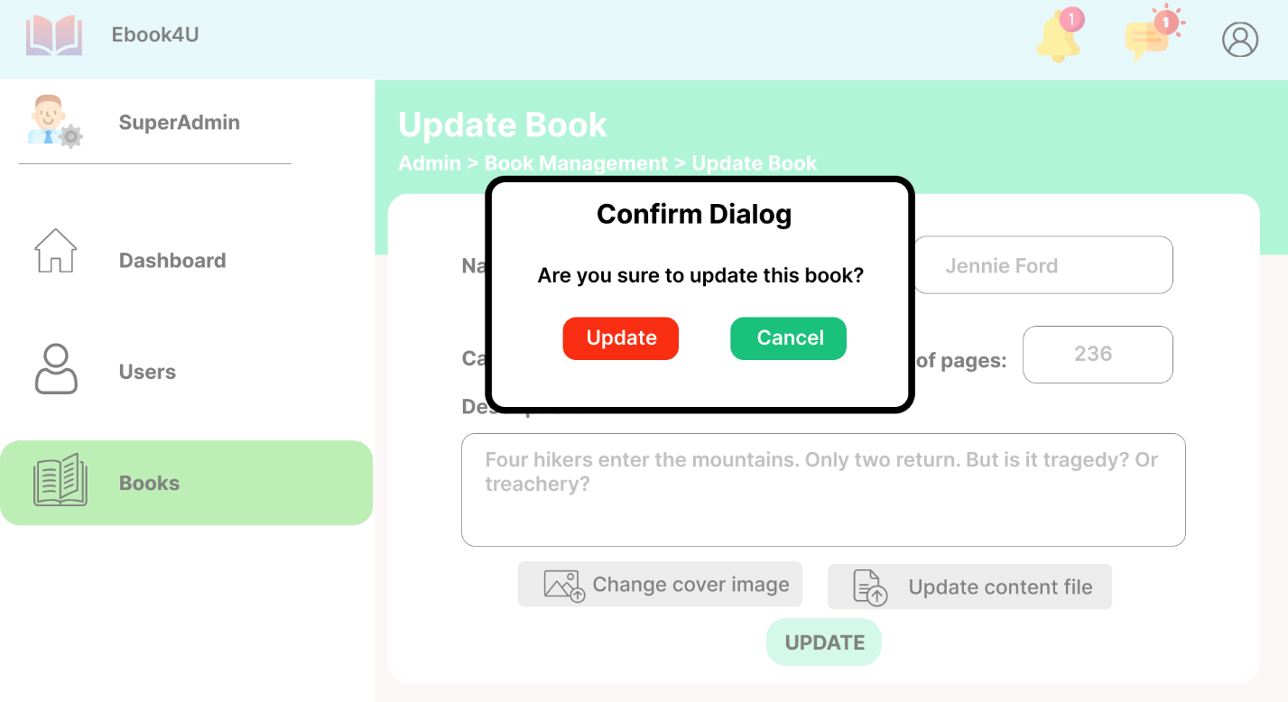

1. **Add new book**

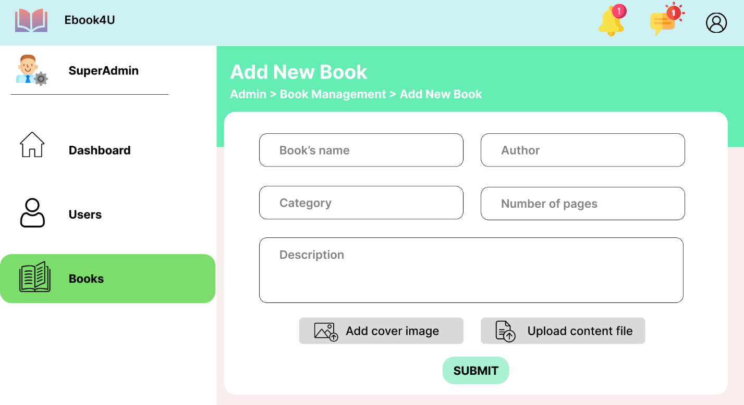

You need to enter all information of the new book.

Click  to add a cover image forr the book

Click 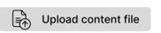 to upload the content file. It can be a .docs, .pdf,… file.